**Test Domain – https://redfynd.com/**

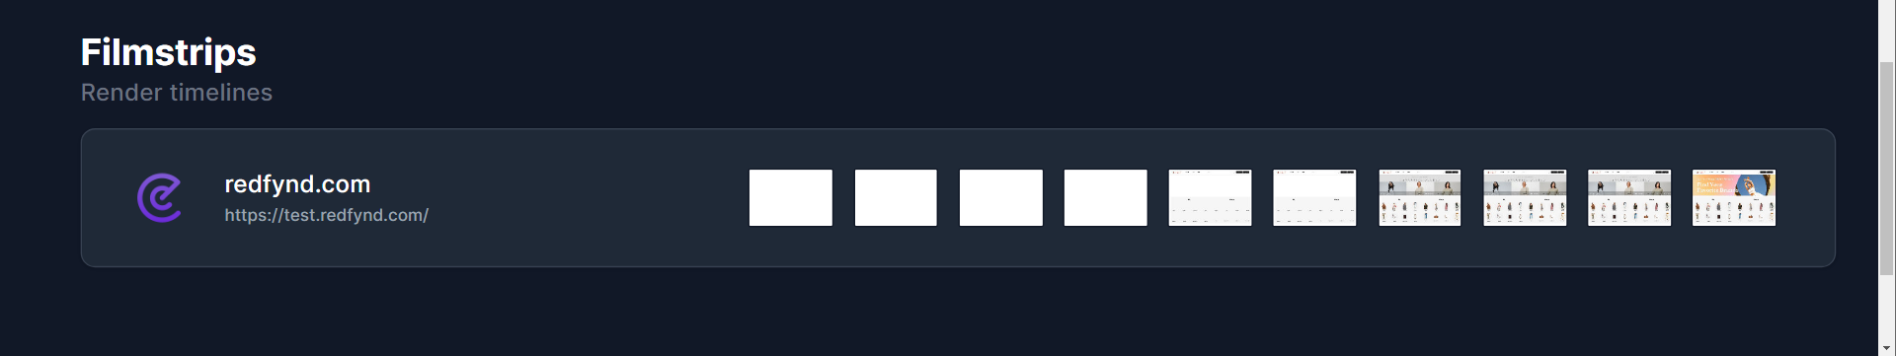

**Test Domain – https://redfynd.com/**

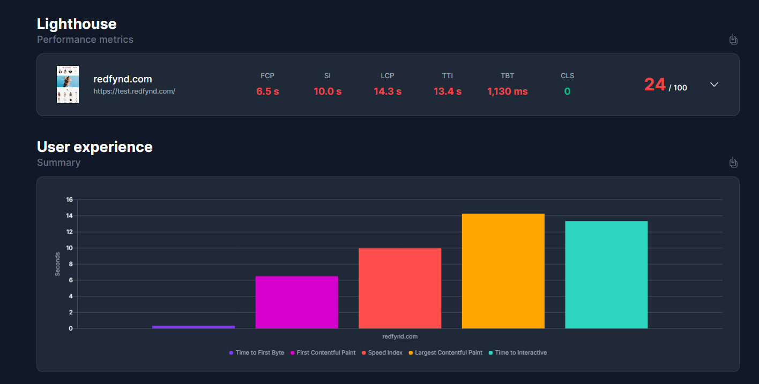

**Test Domain – https://test.redfynd.com/**

**Test Domain – https://test.redfynd.com/**

**Test Domain – https://test.redfynd.com/**

**Test Domain – https://redfynd.com/**

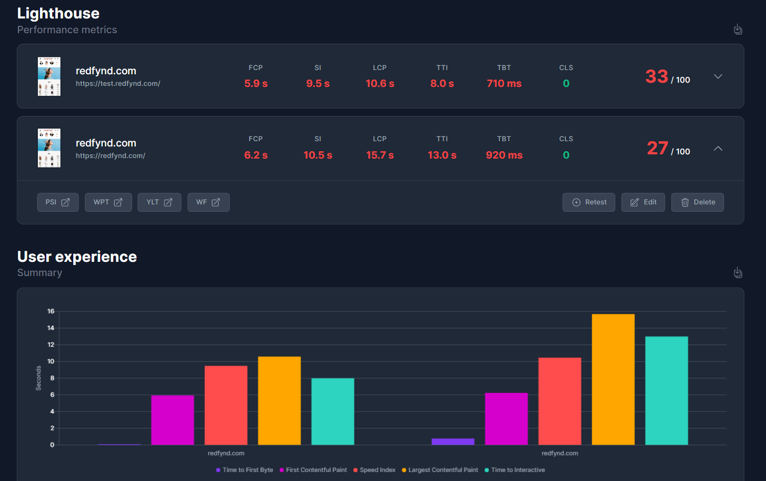

**Test Domain – https://test.redfynd.com/**

**Test Domain – https://redfynd.com/**

**Test Domain – https://test.redfynd.com/**

**Test Domain – https://nykaafashion.com/**

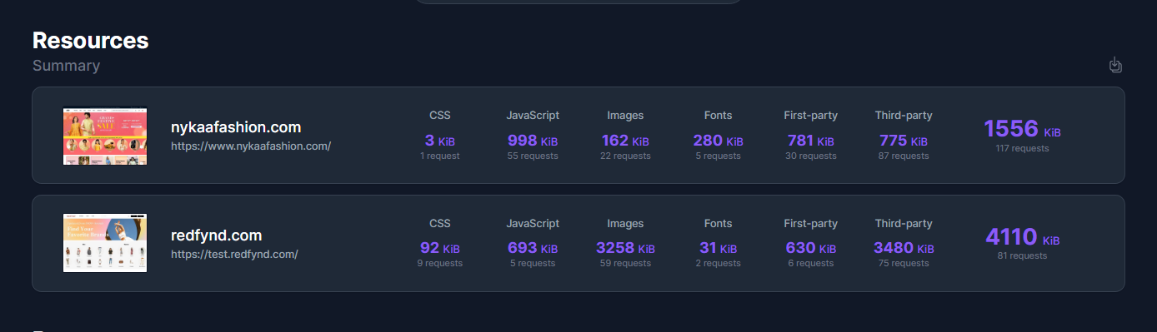

**Test Domain – https://test.redfynd.com/**

**Test Domain – https://nykaafashion.com/**

**Test Domain – https://test.redfynd.com/**

**Test Domain – https://myntra.com**

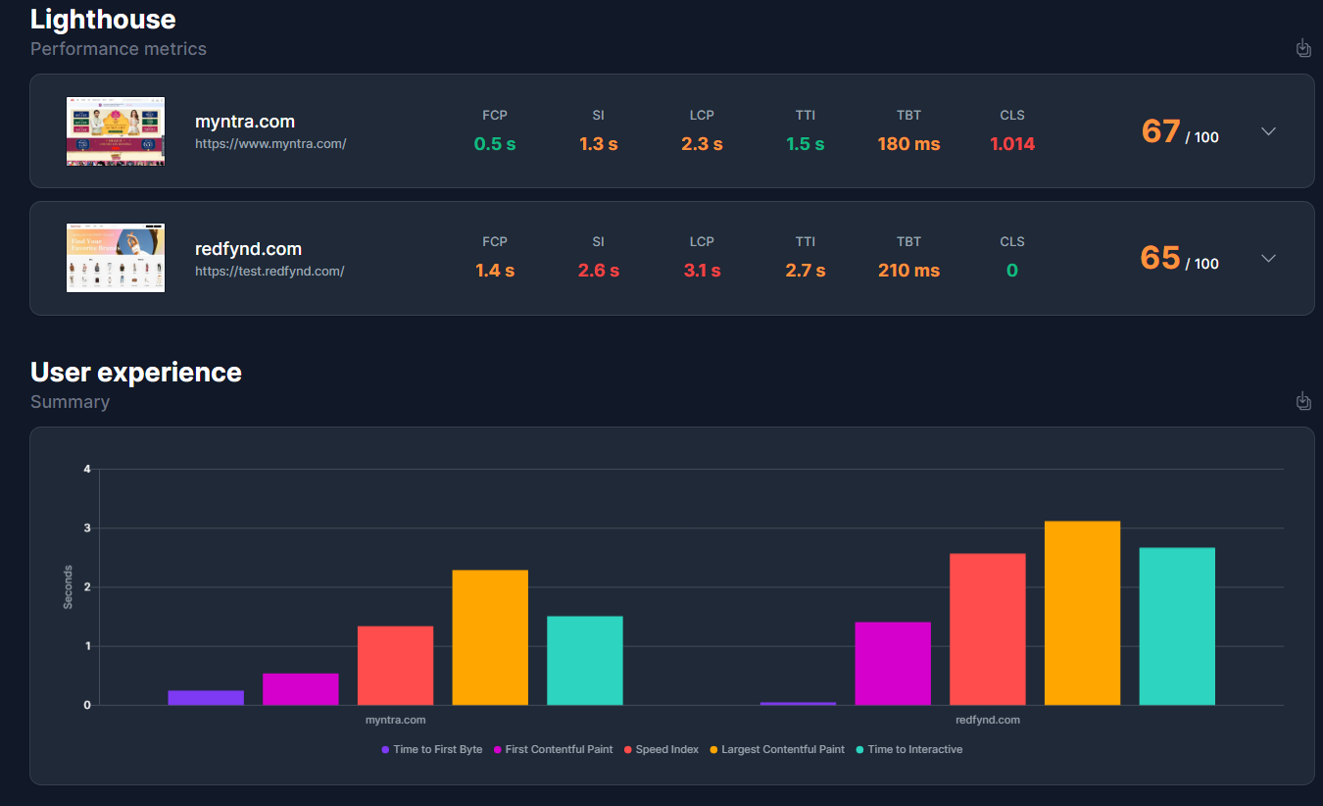

**Test Domain – https://test.redfynd.com/**

**Test Domain – https://myntra.com**

